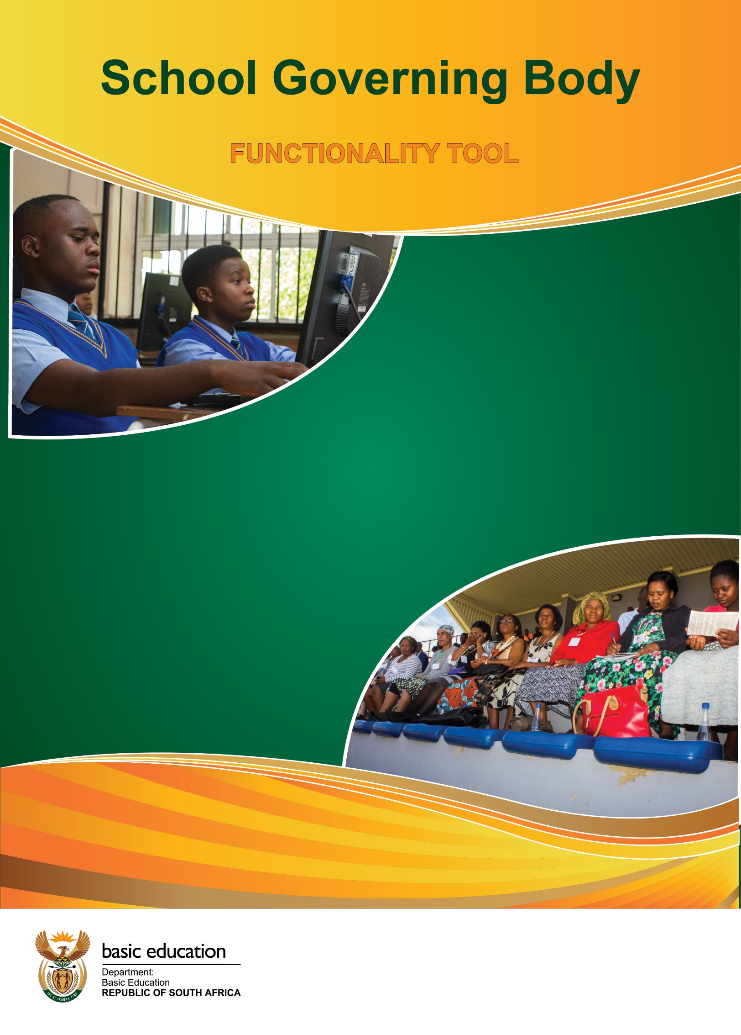

SGB Functionality Tool

- The South African School’s Act No 84 of 1996 (SASA) as amended stipulates that the governance of a school is vested in its School Governing Body (SGB).

- SASA provides for roles and responsibilities that SGBs must perform.

- The SGB Functionality Tool selects key categories from the expected roles for SGBs to self-evaluate their performance and for the Department to assess their functionality in order to determine areas of support and capacity building.

- Each category has 4 statements from which only ONE must be selected as they are arranged in a cascading order which the higher ranking (with evidence) presupposes that the lower criteria have been achieved. Therefore, only one block must be marked with an X per category.

- The School Principal and an SGB representative should administer the first rating and then followed by the moderation by Departmental official based on the evidence provided by the school.

- Both the school and departmental representative must sign the tool.

- The Department of Basic Education or Provincial Education Department will select a sample of schools from those rated for verification purposes.

2020/21 FINAL

Category | Scored by the school  2020/21 SCHOOL GOVERNING BODY FUNCTIONALITY TOOL  Name of School: ___________________ EMIS: ___________________ Province: ___________________ District: ______________________  A Fee Paying: YES/No Quintile___ Type of School: Urban______ Rural _______ Township _______ Farm School_______ |  |  |  |  | Moderated score by official | Comment
Category | Mark with an  X | Mark with an  X | Mark with an  X | Mark with an  X
- SGB Constitution | 0  Not available | 1  Available | 2  Available , Consulted with all members (provide evidence) | 3  Available , Consulted with all members and in line with relevant legislation
- School mission statement | 0  Not available | 1  Available | 2  Available , Consulted with all members (provide evidence) | 3  Available , Consulted with all members and in line with relevant legislation
- Admission Policy | 0  Not available | 1  Available | 2  Available , Consulted with all members (provide evidence) | 3  Available , Consulted with all members and in line with relevant legislation
- Language Policy | 0  Not available | 1  Available | 2  Available , Consulted with all members (provide evidence) | 3  Available , Consulted with all members and in line with relevant legislation
- Religious Observances Policy | 0  Not available | 1  Available | 2  Available , Consulted with all members (provide evidence) | 3  Available , Consulted with all members and in line with relevant legislation
Category |  | Scored by the school |  |  |  | Moderated score by official | Comment
Category | Mark with an  X | Mark with an  X | Mark with an  X | Mark with an  X
- Code of Conduct for Learners | 0  Not Available | 1  Available | 2  Available , Consulted with all members (provide evidence) | 3  Available , Consulted with all members and in line with relevant legislation
- SGB correctly constituted | 0  Not in place | 1  In place | 2  In place and list showing full names and contact details of all SGB members available (provide evidence) | 3  In place and list showing full names and contact details of all SGB members available and all electable categories filled (provide evidence)
- Office-Bearers | 0  Not in place | 1  In place | 2  In place and elected in 2020 (provide minutes) | 3  In place and elected in 2020 and all electable categories of office bearers filled (provide evidence)
- SGB Meetings | 0  Not in place | 1  In place | 2  In place and meetings conducted at least once per term (Provide minutes) | 3  In place and meetings conducted at least once per term and a formal agenda with approved minutes is in place for every meeting (Provide evidence)
- Finance Policy | 0  Not Available | 1  Available | 2  Available and consulted with internal stakeholders (Provide evidence) | 3  Available and consulted with internal stakeholders and in line with relevant legislation
Category | Scored by the school |  |  |  |  | Moderated score by official | Comment
Category | Mark with an  X | Mark with an  X | Mark with an  X | Mark with an  X
- Finance Committee | 0  Not in place | 1  In place | 2  In place and regular meetings held (Provide minutes) | 3  In place, regular meetings held and school finances managed in terms of the school finance policy and SASA provisions (Provide evidence)
- School Budget | 0  Not Available | 1  Available | 2  Budget available and is prepared following acceptable protocols (Provide evidence) | 3  Budget available, prepared following acceptable protocols ,Annual General Meeting/Budget meeting held and budget approved by parents (Provide evidence)
- Learner Support Material | 0  Orders prepared | 1  All internal stakeholders participated (Provide evidence) | 2  All internal stakeholders participated and approved by the SGB (Provide evidence) | 3  All internal stakeholders participated, approved by the SGB and orders placed with the supplier or the Department Adhered to by school (Provide evidence)
- Audited Financial Statements | 0  Not Available | 1  Available | 2  Available, agreed to and signed by the SGB (Provide evidence) | 3  Available, agreed to, signed by the SGB and submitted to the Department (Provide evidence)
- School property, buildings, and grounds | 0  Controls not in place | 1  Controls in place | 2  Controls in place and administered by the SGB (Provide evidence) | 3  Controls in place, administered by the SGB and controls adhered to by the school (Provide proof)

Total rating: __________

Total rating |  | Rating by the Principal | Rating by the Education Official
Functionality level |  | Place x | Place x
5: 37-45 | Works very well
4: 28-36 | Works
3: 19-27 | Almost works
2: 10-18 | Does not work
1: 0-09 | Needs Intervention

Remarks

- NAME OF PRINCIPAL

SIGNATURE:
Telephone/Cell no
DATE:

- NAME OF SGB CHAIR

SIGNATURE:
Telephone/Cell no

DATE:

- NAME OF EDUCATION OFFICIAL
SIGNATURE:
Telephone/Cell no

DATE:



